Using this Template
The following template can be used to help your organization develop a written Hazard Communication Program. This template cannot be used as is – you must customize the template to meet the needs of your organization. We have made this template easy for you to customize by adding visual prompts that identify where your input is needed. These are identified by yellow highlighted text in the template. You may also change any of the text in the template to meet your organization’s needs.
Example:
<Company Name>
Hazard Communication Program

becomes
XYZ Company
Hazard Communication Program

To remove the colored highlighting from your text, left click and drag your mouse over the yellow text and click on the highlighter button from the font menu. To change the font color to black, select the text and click on the font color button.
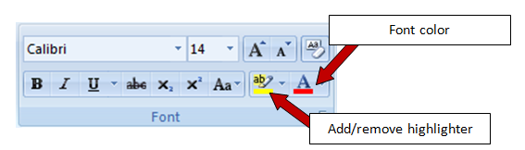

To aid you in understanding the need to customize your program, several “Check Your Understanding” text boxes are also included throughout the template. After reading the information in the text box and adding the required information into the template, you may simply right click on the cross arrow box and select “cut.”
Check Your Understanding. Over 30 million American workers are exposed to hazardous chemicals in their workplaces. Hazard Communication Programs are intended to ensure that these workers and their employers are informed of the identities of these hazardous chemicals, the associated health and safety hazards and appropriate protective measures. When workers have information, they are able to take steps to protect themselves from experiencing adverse effects from chemical exposure. Employees have the right to know the properties and potential safety and health hazards of substances to which they may be exposed.
Goals of Hazard Communication Programs are:
- To help reduce the risks involved in working with hazardous materials
- To transmit vital information to employees about real and potential hazards of substances in the work place
- To reduce the incidence and cost of illness and injury resulting from hazardous substances
- To encourage a reduction in the volume and toxicity of hazardous substances

Disclaimer. This sample safety program template cannot be used as is. You must customize the template to meet the needs of your organization. EMC does not guarantee that this template is or can be relied on for compliance with any law or regulation, assurance against preventable losses, or freedom from legal liability. We make no representations or warranties of any kind whatsoever, either express or implied, in connection with the use of this template. EMC will not be liable for your use of the template as customized by you. All safety programs and policies, including this template and the information you supply to complete it, should be reviewed by your legal counsel and/or risk management staff.

<Company Name>
Hazard Communication Program

Check Your Understanding. Do you need a Hazard Communication Program? If your organization handles any hazardous chemicals, you need to inform and train your employees on the proper personal protective equipment (PPE) to wear and the correct handling practices they should use to remain safe in the workplace. A Hazard Communication Program also describes the methods used to alert all employees of the chemical hazards they may encounter.

Purpose
<Company Name> is committed to the prevention of chemical exposures that may result in injury and/or illness. The purpose of this program is to make sure that all affected employees understand the information concerning the dangers of all known hazardous chemicals used by <Company Name> and to protect company employees who may come in contact with hazardous chemicals while performing their job duties.

All employees are required to follow the procedures outlined in this program. Any deviations from this program must be immediately brought to the attention of the Program Administrator.

Scope

<Company Name> strives to provide all employees and on-site contractors with a safe and healthy workplace. This Hazard Communication Program is integrated into our company’s written safety and health program, and is a collaborative effort that includes all employees. This safety program affects all company employees who may come in contact with hazardous chemicals while performing their job duties.

Exclusions from this program:
- Any substances which are foods, drugs, cosmetics or tobacco products intended for personal consumption by the employees while in the workplace.
- Any consumer products or foodstuffs packaged for distribution to (and intended for use by) the general public.

Program Responsibilities
Management. The management of <Company Name> understands the importance of informing employees of the chemical hazards encountered in the workplace. Management supports the efforts of the Program Administrator <and the Hazard Communication Committee (if applicable)> by pledging financial and leadership support for the program. Management will regularly and effectively communicate with employees about the program.
Hazard Communication Program Administrator. The Program Administrator is responsible for the program’s implementation, management and recordkeeping requirements. The Program Administrator will report directly to upper management and be responsible for this policy and program. All safety data sheet (SDS) evaluations, implemented control measures for chemical handling, PPE requirements and training will be coordinated under the direction of the Program Administrator in collaboration with management. The Program Administrator will monitor the results of the program to determine if additional areas of focus are needed. The Program Administrator will also:
- Develop a list of all hazardous chemicals in the workplace
- Obtain SDS for all hazardous chemicals on-site (sample found in Appendix A)
- Complete a chemical hazard assessment for all hazardous chemicals
- Determine the appropriate PPE for all work tasks involving chemicals
- Obtain and review SDS for new chemicals prior to using the chemical
- Identify where and how all SDS are stored:
  - Central location
  - Chemicals specific to each department
- Ensure annual training is performed and documented (Appendix B)
- Verify that all contractors have a Hazard Communication Program
- Provide the contractors with the hazard communication information necessary to safely complete their tasks
- Conduct an annual review of the Hazard Communication Program and document the review using the proper form (Appendix C)
Managers And Supervisors. Managers and supervisors will:
- Be accountable for the health and safety of all employees within their departments and actively support the Hazard Communication Program
- Attend annual training on the program
- Verify that employees in their areas have received appropriate training
- Ensure that recommended controls are implemented and/or used appropriately
- Notify the Program Administrator when new hazardous chemicals are purchased
- Notify the Program Administrator when new employees are hired
Employees. Every employee is responsible for conducting himself/herself in accordance with this policy and program. All employees will:
- Attend hazard communication training as required and apply the knowledge and skills acquired to all work activities
- Become familiar with label information, including pictograms
- Become familiar with the 16 sections of SDS
- Use appropriate PPE for the chemicals and tasks being performed

Check Your Understanding. To prepare a Hazard Communication Program, it is necessary to complete the following tasks:
- Develop a list of all hazardous chemicals in your facility
- Acquire SDS for every hazardous chemical in your facility (continue to update SDS with the 16 section data sheets as they become available)
- Review all SDS, perform a Job Hazard Analysis and determine which type of PPE should be used while using the chemicals
- Provide proper labeling of containers/secondary containers including appropriate signal words, hazard statements, precautionary statements and pictograms

Chemical Inventory List
<Company Name> maintains a list of the hazardous chemicals currently present in the workplace (see below). This list is periodically reviewed and updated by the Program Administrator. The list is cross-referenced with the SDS and is kept with this program and SDS to serve as an index to help employees identify and locate necessary information.
Chemical Name | Manufacturer | Location Used | SDS (Y/N)

Safety Data Sheets (SDS)
Check Your Understanding. SDS must be readily available to employees in their work area(s) and during all shifts. This may be accomplished in a variety of ways, so it is up to you to decide which method is appropriate for your particular workplace. Some employers keep the SDS in a binder in a central location, such as the supervisor’s office or the job site trailer. Others, particularly in workplaces with a large number of chemicals, keep electronic copies and provide access at computer terminals. As long as employees can get the information when they need it, any approach may be used.
These sheets provide detailed information on each hazardous chemical, including its potentially hazardous effects, its physical and chemical characteristics and recommendations for appropriate protective measures.
The Program Administrator obtains the necessary SDS for all hazardous materials. SDS are kept at <Location or Computer Program Name>, and are available to all employees on all shifts who wish to review them or need them for emergency information.
Employees who require emergency medical treatment after exposure to a chemical should take a copy of the SDS to the medical facility.
Container Labeling

The chemical manufacturer, importer or supplier is responsible for labeling the chemical containers received by <Company Name>. Employees receiving chemical shipments are responsible for ensuring the chemical containers are labeled. If the chemical containers are not labeled or if the label is damaged, contact the Program Administrator. The Program Administrator is responsible for reviewing the receiving process and confirming the proper labels are on all chemical containers. Chemicals transferred to secondary containers in the workplace must also be appropriately labeled.

The procedures for proper labeling of all containers are as follows:
- Inspect incoming containers to ensure they have legible labels
- Manufacturer chemical labels should never be removed or defaced until the chemical is completely used; Empty containers that are saved for reuse must have the original label removed or marked out and obliterated; Empty containers that are used for waste or chemical products must have a new label affixed or have the information written directly on the container
- Secondary containers must be labeled with the chemical name and hazard when the substance is transferred from the primary container to a secondary container
- All chemical storage areas such as cabinets, shelves and refrigerators must be labeled to identify the hazardous nature of the chemicals stored within the area (e.g., flammables, corrosives, oxidizers, etc.). All signs should be legible and conspicuously placed

<Company Name> will use labels identical to those supplied by the manufacturer, importer or supplier for all secondary containers used. No containers or chemicals will be used if not properly labeled. If there is a question about the accuracy of the label or if a container is not labeled, contact the Program Administrator immediately. (See label example in Appendix A)

Employee Training
<Company Name> provides employees with information on any operations in their work area(s) where hazardous chemicals are present, the location of the written Hazard Communication Program, chemical listings and the location of SDS. Training will be provided on the job and in a classroom setting prior to first exposure to a hazardous material, and will cover the specific chemicals the employee is exposed to and their associated hazards. Chemical-specific information will always be available through labels and SDS. Attendance at all training is mandatory. Refresher training will be conducted at least annually.
Employee training will cover the following items:
- Any operation in their work area(s) where hazardous chemicals are present
- The location and availability of the written Hazard Communication Program, including the required list(s) of hazardous chemicals, labels and SDS
- Methods and observations that may be used to detect the presence or release of a hazardous chemical in the work area(s) (such as monitoring conducted by the employer, continuous monitoring devices, visual appearance or odor of hazardous chemicals when being released, etc.)
- Describe the labeling system, including the labels with the signal words, hazard statements, precautionary statements and pictograms. (example label found in Appendix A)
- The physical and health hazards of the chemicals in the work area(s) and where this information can be found on the chemical label and SDS
- The measures employees should take to protect themselves from these hazards, including specific procedures the employer has implemented to protect employees from exposure to hazardous chemicals, such as appropriate work practices, emergency procedures and personal protective equipment to be used
- The details of the Hazard Communication Program, including an explanation of the SDS, and how employees can obtain and use the hazard information
- The periodic requirement for employees to perform non-routine tasks that may involve hazardous materials and the information given to them before starting work by their supervisor regarding the potential exposure hazards
Training will also be provided on an as-needed basis when new hazards are introduced into the workplace, when new hazards are discovered, and/or when new information on a SDS has been revised. All training will be documented on the employee training form (Appendix B) and retained by the Program Administrator.
Periodic Program Review
All hazard communication procedures and training are reviewed by the Program Administrator annually.
Annual inspections are documented with the form shown in Appendix C and maintained by the Program Administrator.
Outside Contractors
Subcontractors working on our property or job site are required to bring copies of SDS for all hazardous materials they are bringing on the site. These will be kept in <Location> so the information is accessible to all employees. Each subcontractor must bring its specific Hazard Communication Program and SDS in a binder labeled with the contractor's name and identified as a Hazard Communication Program. Upon leaving the jobsite and the removal of all hazardous materials, they may take their SDS and Hazard Communication Program with them.

Contractors working on the company's property or job site will be informed of the <Company Name> written Hazard Communication Program and where to locate SDS. It will be the responsibility of that employer to properly train his or her employees on the avoidance and/or emergency procedures for these materials.

Record Retention
All hazard communication training and program review records will be retained for ten years.
All SDS will be archived and retained indefinitely.

Revision History
<Revision 1 –Month, Year>

Appendix A – Label Example

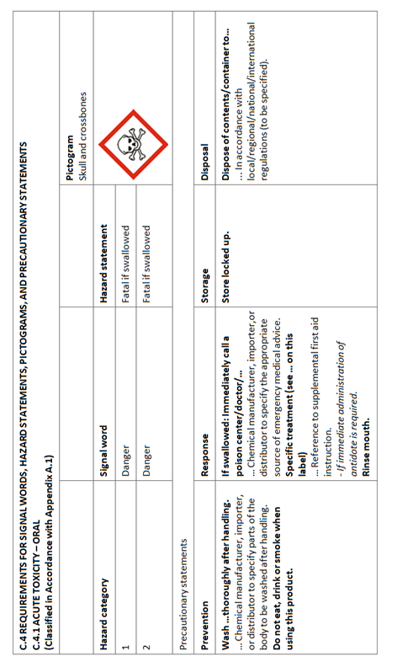
Appendix B – Employee Training Record
The following individuals received training on this <Company Name> Hazard Communication Program.

Print Name | Sign Name | Date

Print Instructor’s Name
Instructor’s Signature
Instructor’s Title
Date of Training

Appendix C – Annual Evaluation Report
Date of Evaluation: | Evaluated by (list all present):
Written Program Reviewed: Yes No
Comments on Written Program:
The following specific chemical handling procedures have been reviewed:
The following specific chemical handling procedures were modified:
The following specific chemical handling procedures were added:
A review of the chemical inventory was made: Yes No

